QUICK GUIDE TO SAFEGUARDING ADULTS AT RISK

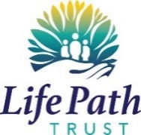 | All people working with adults at risk of abuse and neglect have a role to play in preventing it, responding to it and reporting it.  People making use of Life Path services may be at risk.

THE LEGAL STUFF: the 2014 CARE ACT sets out the legal framework for safeguarding. It defines what abuse is, the principles of safeguarding, who is responsible for what (especially how Local Authorities must manage safeguarding)

What is safeguarding adults?  ‘Safeguarding adults’ means helping adults, who may be at risk, to stay free from abuse and neglect. It used to be called ‘Adult Protection’. |  | Who is an adult at risk?  An ‘adult at risk’ is someone who is 18 years or over and needs community care services. As a result of their mental or other disability, age or illness, they may find it difficult to protect themselves from abuse

WHAT ARE THE TYPES OF ABUSE?
- Physical abuse Domestic violence or abuse Sexual abuse Psychological or emotional abuse Financial or material abuse Modern slavery Discriminatory abuse Organisational or institutional abuse Neglect or acts of omission Self-neglect
Living a life that is free from harm and abuse is a fundamental human right and an essential requirement for health and well-being.

Empowerment: Personalisation and the presumption of person-led decisions and informed consent. The person is asked what they want from the safeguarding process and these directly inform what happens. | 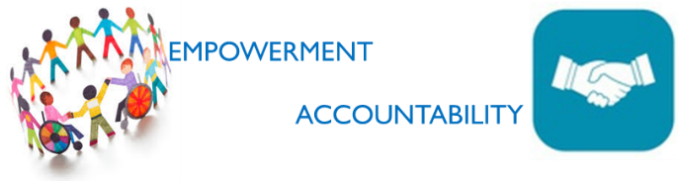 | Accountability: Accountability and transparency in delivering safeguarding. The person can understand the role of everyone in their life.
Prevention: It is better to take action before harm occurs. The person receives clear and simple information about what abuse is and how to recognise signs and what they can do to seek help. |  | Partnership: Local solutions through services working with their communities. Communities play a part in prevention, identifying and reporting neglect and abuse.
Proportionality: The right level of response from professionals who will work in the best interest of adult at risk and will only be involved as much as needed. |  | Protection: Support and representation for those in greatest need. The person gets help to report abuse and get support to take part in the safeguarding process. As much or as little as they want.

Always speak up if you have concerns that someone is at risk. Start by talking to your manager or other senior person who can help you understand a situation if you are unsure.
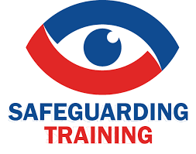
Life Path requires you to Always attend your Safeguarding Training and undertake your annual safeguarding tests Your managers will be doing more work with you throughout the year in your supervision and team meetings about Safeguarding. Remember to Always speak up if you have concerns that someone is at risk. Start by talking to your manager or other senior person who can help you understand a situation if you are unsure.

Worried about speaking out? Use the Whistleblowing Policy. Get a copy from the HR team.
Remember it’s your responsibility to play your part in safeguarding the Citizens who access Life Path Trust Services’
All people working with adults at risk of abuse and neglect have a role to play in preventing it, responding to it and reporting it.

People making use of Life Path services may be at risk. If you are worried don’t delay speak up .

RESPONSE TO SAFEGUARDING ALERT

 | Activity |  | Responsibility |  | Timescale
Safety from immediate harm |  | - Contact emergency services if required:  Ambulance if person requires medical attention  Police if person is at immediate risk of further harm |  | Staff/volunteer who find a person in immediate need / at immediate risk | Immediately
Deal with immediate needs |  | - Ensure person is in a calm supported environment safe from further harm;  - Provide reassurance to the person at risk / who has made a disclosure  - Seek medical advice if needed |  | Staff/volunteer who finds person at risk | Immediately
Raising a concern / alert |  | - Report to person responsible for safeguarding:  Line Manager  Senior Manager  On-call manager |  | Staff/volunteer who finds person at risk | Immediately
DOCUMENT |  | Staff should start an Action / Decision log as soon as possible once all persons involved are safe and comfortable.
Staff / volunteer are required to ensure the immediate safety from harm / medical needs of the person are looked after, and to report issue.
Staff / volunteer must never: clean, disrupt potential evidence, question person or others who may be involved / perpetrators.
Staff /volunteer should not question OR discuss with others, other than the person they are reporting to. Remember Confidentiality at all times.

