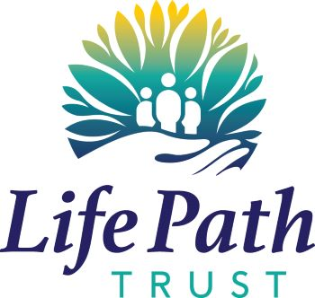

Life Path Trust Ltd
Gender Pay Gap Report 2022
We have prepared our gender pay gap report and present that report with our thoughts and plans for addressing the findings.
Whilst our pay gap is negative for 2021 this work will inform our commitment to ensure we develop a more diverse and inclusive organisation.
Results
This report has been prepared using the 5th April 2021 snapshot date. Life Path paid no bonus in this period.
The figures have been calculated using the methodologies used in the Equality Act 2010 (Gender Pay Gap Information) Regulations 2017.
2021 2020
Mean (average) gender pay gap 0% -2%
Median (mid-point) gender pay gap -1% 0%
The quartile analysis is as follows with A being the lower quartile and D being the top quartile.
Band | Male | Female
A | 6.35% | 93.65%
B | 17.46% | 82.54%
C | 14.29% | 85.71%
D | 12.70% | 87.30%

What are the underlying causes of Life Path’s gender pay gap?
The majority of our staff are female (2021: 87%, 2020: 87%) and the care sector has historically attracted more woman than men. We operate a set pay scale which does not differentiate between genders.
What are we doing at Life Path to address the gender pay gap?
Further Analysis
No further analysis is required.
Diversity and Inclusion Awareness
We will look at running training for existing staff to raise awareness of diversity and inclusion. All new staff will have such training as part of their induction process.
Reporting
Life Path is committed to reporting on an annual basis.
Thank you for taking time to read our report and any enquires can be directed toward our HR team at the office on 02476 650530.

I, Caroline Mitchell, Finance Director, confirm that the information in this statement is accurate.

Signed
Caroline Mitchell

Date: 08 March 2022

