Connect2
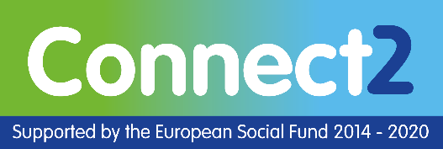
Connect2 is for people aged 16+ who are unemployed or inactive who live in Coventry.
Connect2 can help you address labour market barriers such as disabilities and mental health issues. The project understands the unique and complex barriers which deters people from engaging in employment focused programmes.
Connect2 can support you in a range of ways, including:
- getting into education, training or employment
- one to one guidance
- employability coaching
- skills development
- raising aspirations, resilience and independence
- skills and confidence building.

Who we work with
Coventry & Warwickshire Chamber of Commerce Training
Can help you build your skills through short courses in various subjects, leading on to traineeships and apprenticeships.
Coventry Refugee and Migrant Centre
Supports you to overcome self confidence, self motivation and other personal development issues and offers English language classes to help you succeed in the world of work.
Coventry University Social Enterprise
Will support you to develop your employability and enterprise skills through a specially developed programme. You will be helped to overcome the personal and social challenges you face so you are better equipped to enter the workforce.
Disruptive Media Learning Lab at Coventry University
Can help you to develop your communication, problem solving and creative thinking skills so you can engage with further training and the labour market.
Foleshill Women's Training (FWT)
Offers you a range of courses including English, Maths, ESOL and basic IT skills for employment and job support. FWT can support you with confidence building and access to childcare.
Internally Provided Services, Coventry City Council
Will help you work through barriers such as fear, anxiety and low expectations so you can access good quality and supported opportunities as part of your personalised pathway to employment.
Life Path Trust
Offers you one to one support to access work experience, voluntary roles and employability courses. In addition, you can access training in areas including food hygiene, first aid and manual handling.
New Start 4U
Will support you with employability, motivational and confidence building workshops and career advice and guidance.
Rethink Mental Illness
Offers you an in-depth assessment of your skills, experience and support requirements leading to a personal action plan which sets out the steps to achieve your goals.
The Job Shop, Coventry City Council
Supports you with workshops and one to one employment support, plus can help you to apply for jobs and placements with local employers.
Working Actively to Change Hillfields
Can support you with a weekly jobs club, CV preparation, interview techniques and completing job application forms. In addition, Hillz FM delivers the popular 'Introduction to Radio' programme.

